Name: Umair Ahmad Roll no: Su92-bsaim-F25-109
Class: BSAI-3B subject: Artifical intelligence (lab)
Instructor: Sir Rasikh Ali
Task 1:
Trace BFS and DFS manually:
Original graph: A:[B,C], B:[D,E], C:[F], D:[], E:[G], F:[], G:[]. Start=A; Goal=G.
graph = { "A": ["B", "C"],"B": ["D", "E"],"C": ["F"],"D": [], "E": ["G"],"F": [],"G": []}
def bfs(start, goal):
q = deque([(start, [start])])
seen = {start}
order = []
while q:
node, path = q.popleft()
order.append(node)
if node == goal:
return path, order
for n in graph[node]:
if n not in seen:
seen.add(n)
q.append((n, path + [n]))
def dfs(start, goal):
stack = [(start, [start])]
seen = set()
order = []
while stack:
node, path = stack.pop()
if node in seen:
continue
seen.add(node)
order.append(node)

if node == goal:
return path, order

for n in reversed(graph[node]):
stack.append((n, path + [n]))
print("BFS:", bfs("A", "G"))
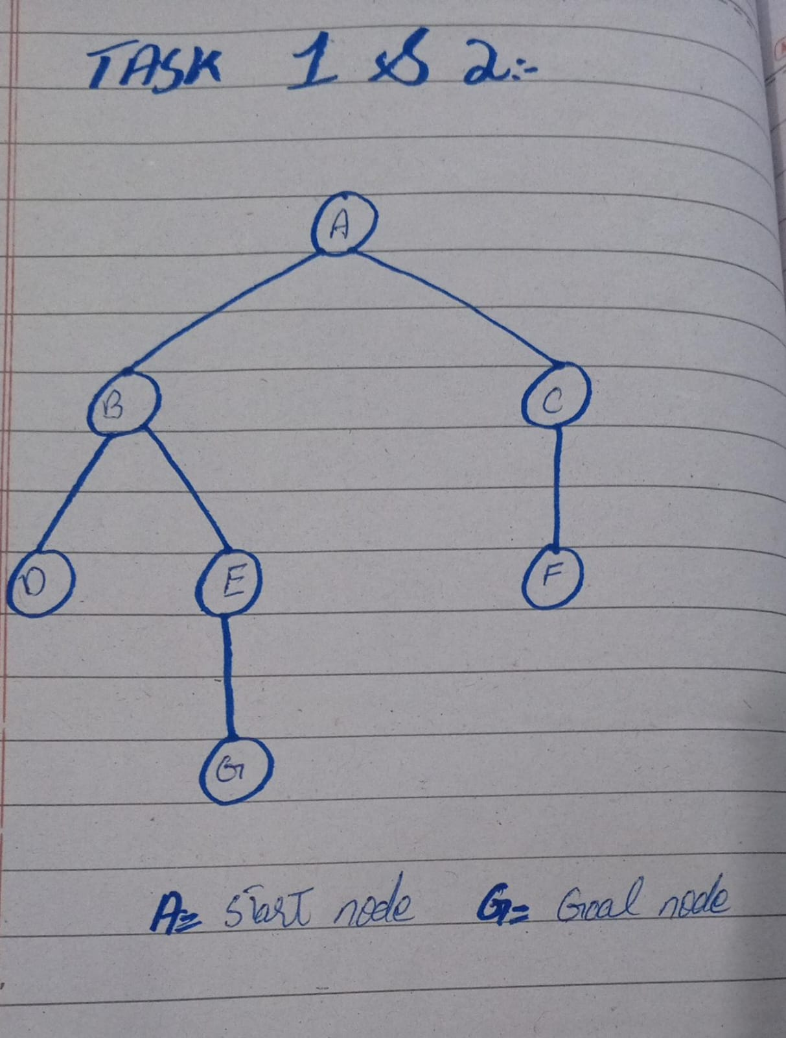
print("DFS:", dfs("A", "G"))

Task 2
Implement DLS and IDDFS:
graph = {"A": ["B", "C"], "B": ["D", "E"],"C": ["F"],"D": [],"E": ["G"],"F": [],"G": []}
def dls(node, goal, limit, path):
if node == goal:
return "FOUND", path
if limit == 0:
if graph[node]:
return "CUTOFF", None
return "FAILURE", None
cutoff = False
for child in graph[node]:
if child in path:
continue
status, result = dls(
child, goal, limit - 1,
path + [child] )
if status == "FOUND":
return status, result
if status == "CUTOFF":
cutoff = True
if cutoff:
return "CUTOFF", None
return "FAILURE", None
def iddfs(start, goal, max_depth):
for limit in range(max_depth + 1):
status, path = dls(
start, goal, limit, [start])

print("Limit:", limit,
"Status:", status, "Path:", path)
if status == "FOUND":
return path
return None
for limit in [1, 2, 3, 4]:
print("DLS limit", limit, ":",
dls("A", "G", limit, ["A"]))
print("IDDFS results:")
iddfs("A", "G", 4)

Task 3
Weighted graph and Uniform Cost Search (UCS):
import heapq

graph = {"A": [("B", 1), ("C", 2)],"B": [("D", 4), ("E", 1)],"C": [("F", 5), ("G", 10)],"D": [],"E": [("G", 1)],"F": [], "G": []}

def ucs(start, goal):
pq = [(0, start, [start])]
best = {start: 0}
order = []
while pq:
cost, node, path = heapq.heappop(pq)
if cost != best.get(node):
continue
order.append(node)
if node == goal:
return path, cost, order
for nxt, weight in graph[node]:
new_cost = cost + weight
if new_cost < best.get(nxt, float("inf")):
best[nxt] = new_cost
heapq.heappush(
pq, (new_cost, nxt, path + [nxt]))
return None, float("inf"), order
path, cost, order = ucs("A", "G")
print("UCS Path:", path)
print("Total Cost:", cost)
print("Processing Order:", order)

Edge-case tests and interpretation:
1. Start equals goal: searching A to A should return [A] immediately. 2. Unreachable goal: search for a nodenot in/reachable from the graph should report no path; guard against missing graph keys if testing unknown nodes.
3. Cycle test: add an edge back to an ancestor, such as E → B; the path-local check prevents infinite recursion in DLS/IDDFS. A depth limit of 2 only means the goal was not found within depth 2; it does not prove the goal is unreachable.

